**CUBC Project**

**Installation Guide**

Step 1. Download Microsoft Visual Studio Code from <https://code.visualstudio.com/> and Install it

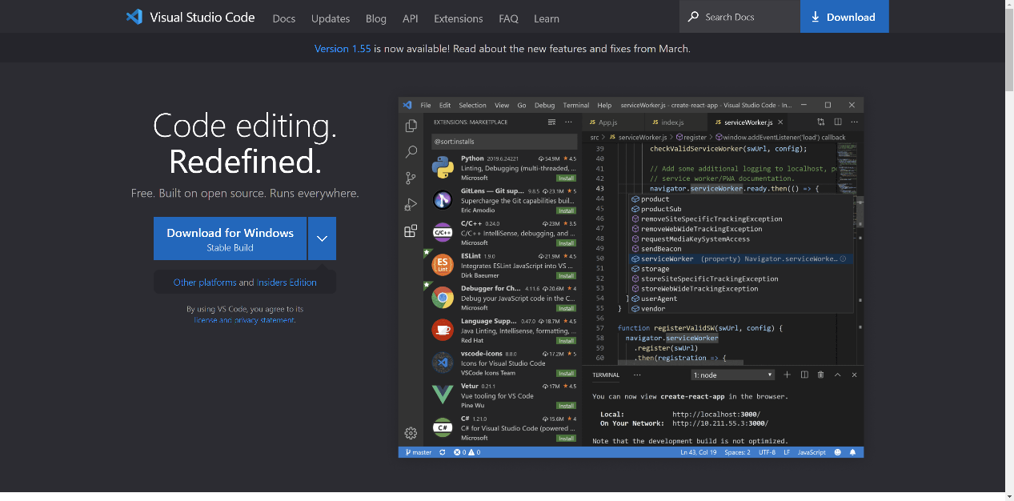

Step 2. Download Node.js from <https://code.visualstudio.com/> and Install It

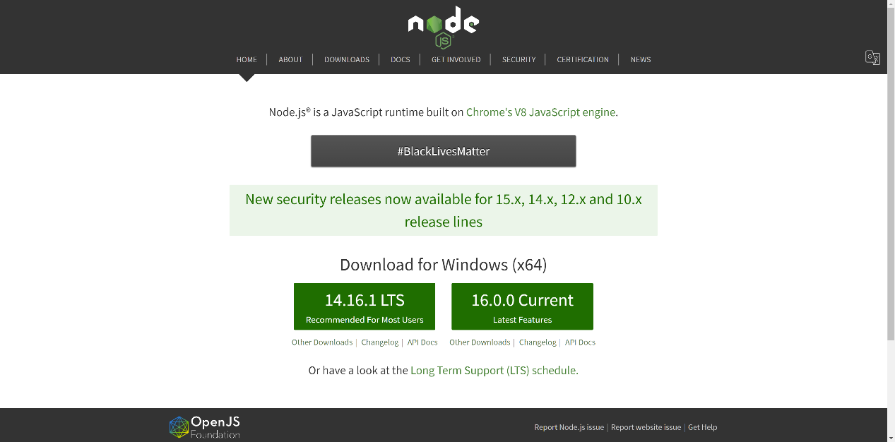

Step 3. Open Terminal and type command “npm install sails -g” to install Sails.js

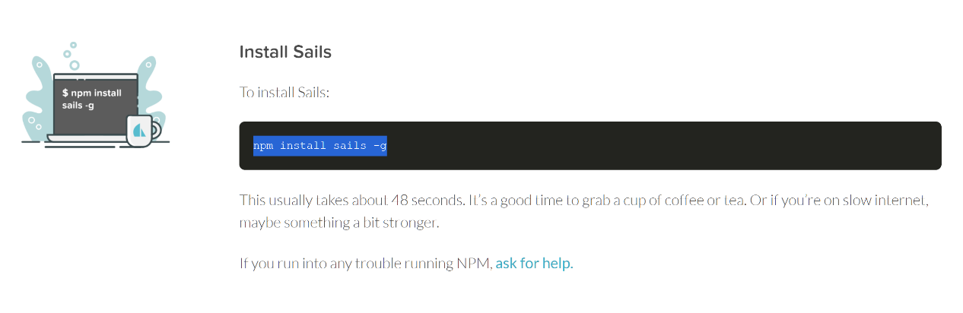

Step 4. Download the source code zip file, unzip it and open the folder with Visual Studio Code

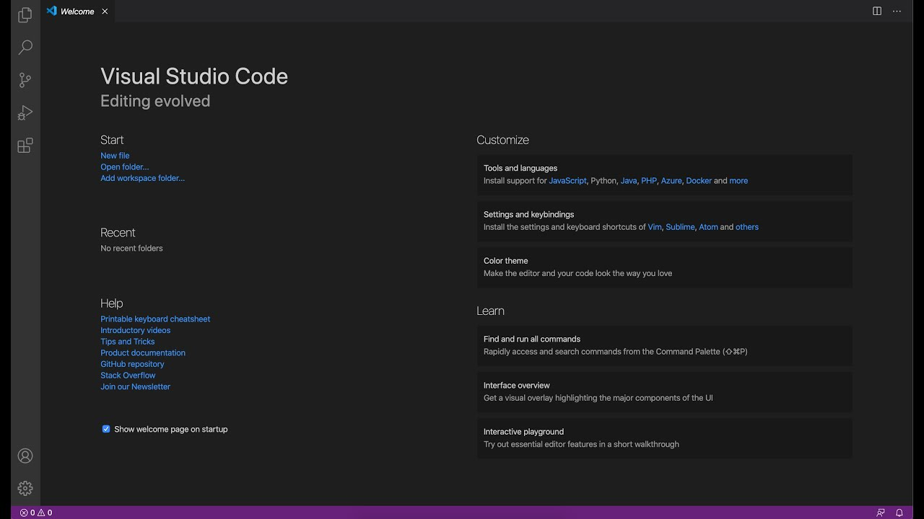

Step 5. Open Terminal and input command “npm install”

Step 6. Input command “sails lift” to run the system

For not altering the current data: Input 1

For removing all the current data: Input 2

Step 7. Open browser and type the link <http://localhost:1337/>

Initial User account:

Account: jay password: 123456

Initial Admin account:

Account: admin password: 123456